**Project Design Phase-II**

**Data Flow Diagram &User Stories**

|  |  |
| --- | --- |
| Date | 12 October 2022  . |
| Team ID | PNT2022TMID33057 |
| Project Name | Plasma Donor Application |
| Maximum Marks | 4 Marks |

**Data Flow Diagram:**

A Data Flow Diagram (DFD) is a traditional visual representation of the information flows within a system. A neat and clear DFD can depict the right amount of the system requirement graphically. It shows how data enters and leaves the system, what changes the information, and where data is stored.

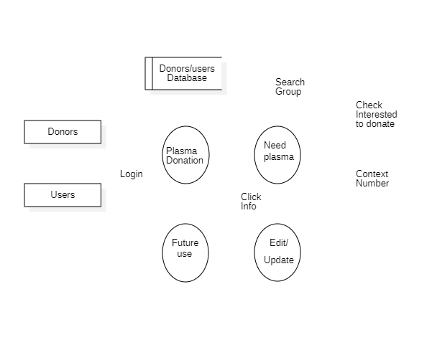

**User Stories:**

| **User Type** | **Functional Requirement (Epic)** | **User Story Number** | **User Story / Task** | **Acceptance criteria** | **Priority** | **Release** |
| --- | --- | --- | --- | --- | --- | --- |
| Customer (Mobile user) | Registration | USN-1 | As a user, I can register for the application by entering my email, password, and confirming my password. | I can access my account / dashboard | High | Sprint-1 |
|  | Confirmation | USN-2 | As a user, I will receive confirmation email once I have registered for the application | I can receive confirmation email & click confirm | High | Sprint-1 |
|  | Access application | USN-3 | As a user, I can register for the application through application | I can register & access the application | Low | Sprint-2 |
|  | Registration Gmail | USN-4 | As a user, I can register for the application through Gmail | I can receive successful  registration Gmail | Medium | Sprint-1 |
|  | Login | USN-5 | As a user, I can log into the application by entering email & password | I can enter into application successfully | High | Sprint-1 |
| Customer (Web user) | Access Website | USN-6 | Capable to access web application through an browser | I can access web-application | Medium | Sprint-1 |
|  | Search for donor | USN-7 | Search result can be viewed in a list | I can view list represents a specific donor with donor details | High | Sprint-1 |
| Customer Care Executive | Software Operator | USN-8 | Should be able to register through application. Donor must provide username, gender, blood group, location, contact. | The user’s response surprised us positively | High | Sprint-1 |
|  | View request | USN-9 | The customer care executive should be able to view received request and then respond to them | We can receive the request response immediately | High | Sprint-1 |
| Administrator | Maintenance | USN-10 | Admin can access, view, modify, update all details of the plasma donor application | Admin is the authorized person of the overall application. | High | Sprint-1 |